Ideation Phase
Empathize & Discover

Date | 31 January 2025
Team ID
Project Name
Maximum Marks | 4 Marks

Empathy Map Canvas:
An empathy map is a simple, easy-to-digest visual that captures knowledge about a user’s behaviours and attitudes.

It is a useful tool to helps teams better understand their users.
Creating an effective solution requires understanding the true problem and the person who is experiencing it. The exercise of creating the map helps participants consider things from the user’s perspective along with his or her goals and challenges.
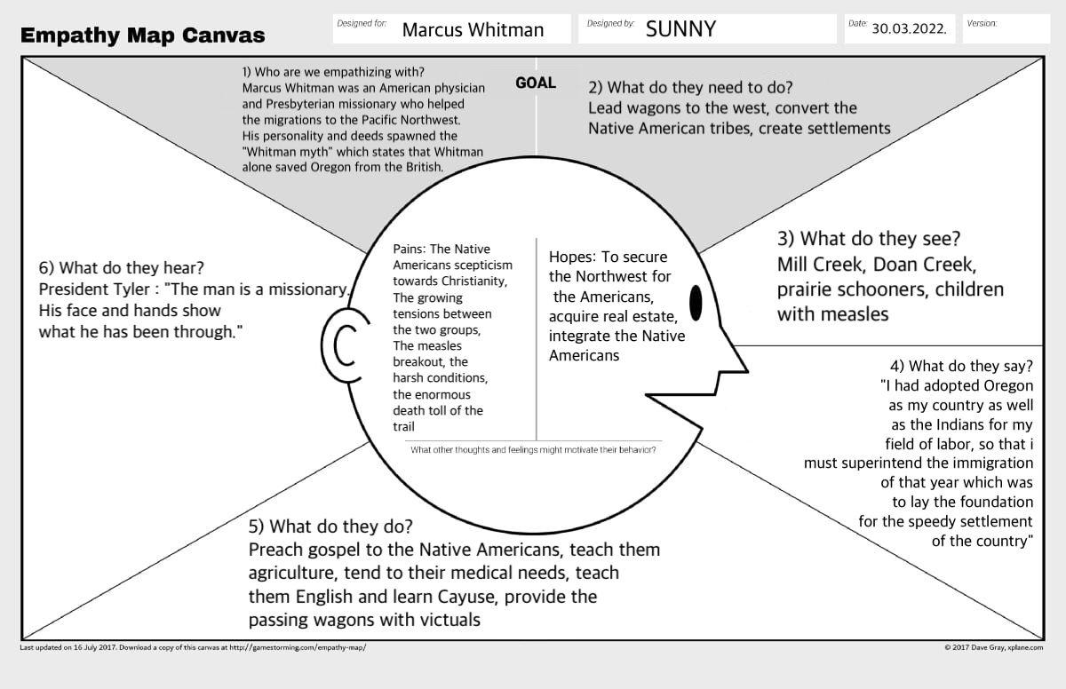
SAYS:
- Managing records takes time
- I need one system
- Data should be secure.
THINKS:
- Easy client management
- Accurate meal plans
- Quick access to data.
DOES:
- Registers clients
- Creates meal plans
- Tracks progress.
FEELS:
- Frustrated with manual work
- Wants a simple solution
- Needs secure storage.
SEES:
- Paper records
- Excel sheets
- More clients
- Need for digital management.
PAINS:
- Manual work
- Time-consuming
- Difficult tracking
- Record loss.
GAINS:
- Saves time
- Better management
- Secure records
- Improved productivity

